ASE LAB 8
Step 1:
- Firstly Open the docker desktop
- Then run this command:
docker run -d --name sonarqube -e SONAR_ES_BOOTSTRAP_CHECKS_DISABLE=true -p 9000:9000 sonarqube:latest
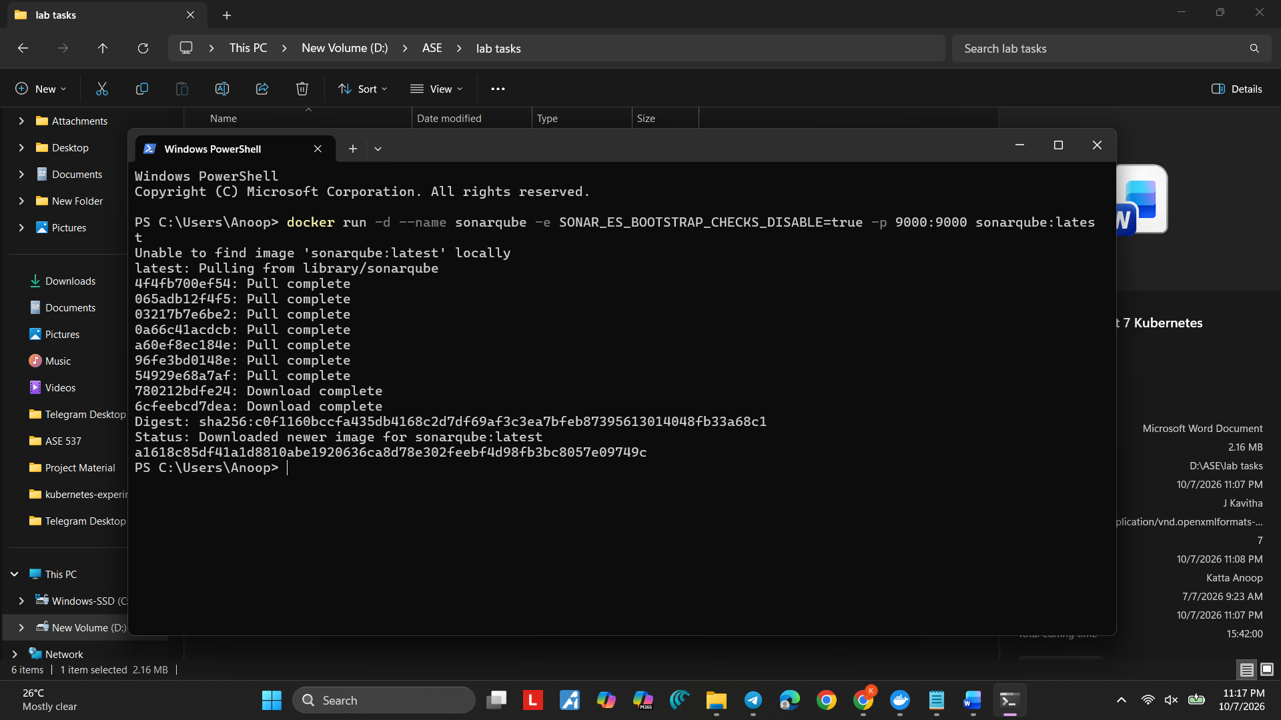
- Wait until the command and then run: docker ps

If u see output like this:
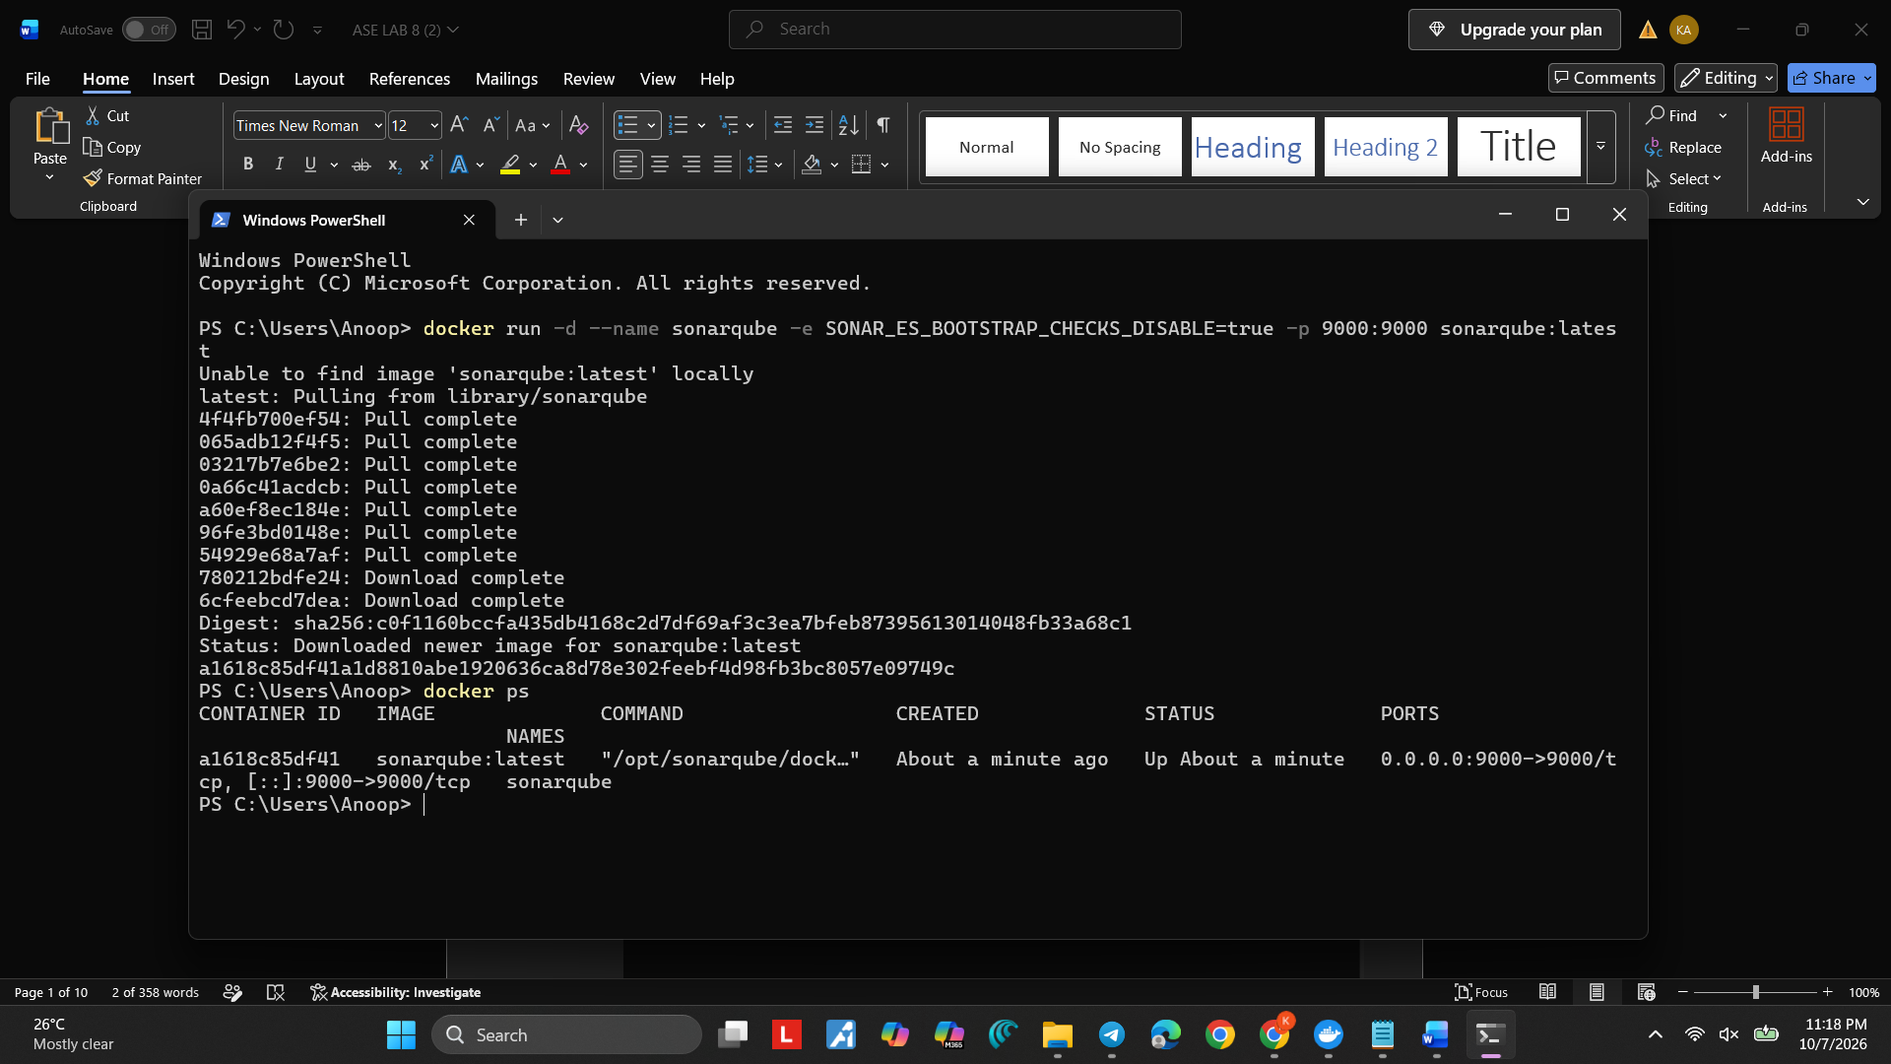
Then The image has been installed successfully
Step 2: Open sonarqube using localhost
http://localhost:9000
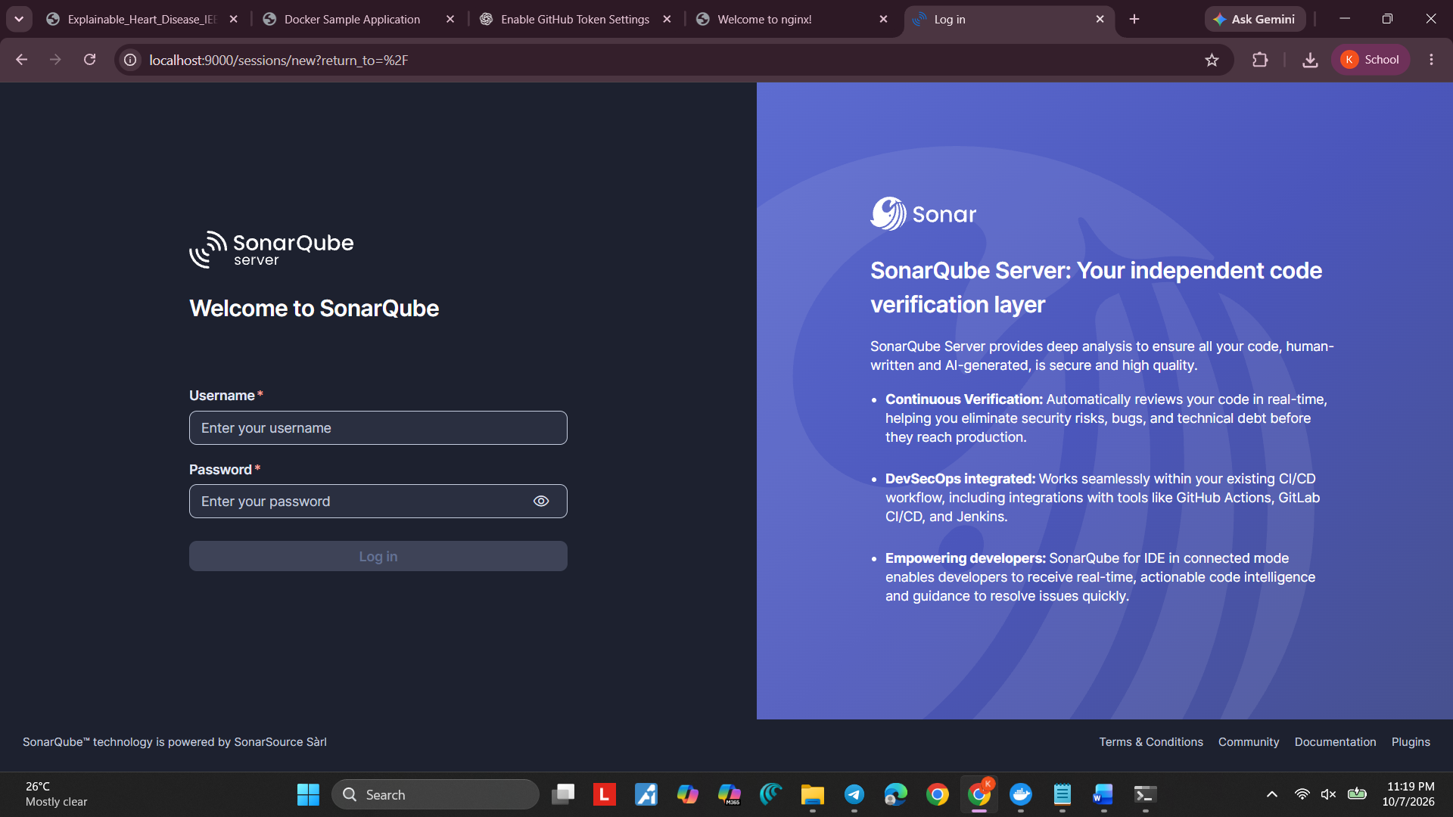
- Then login using the credentials:
Username: admin
Password: admin
Step 3: Create the SonarQube project
Project Name: Banking
Project Key: Banking
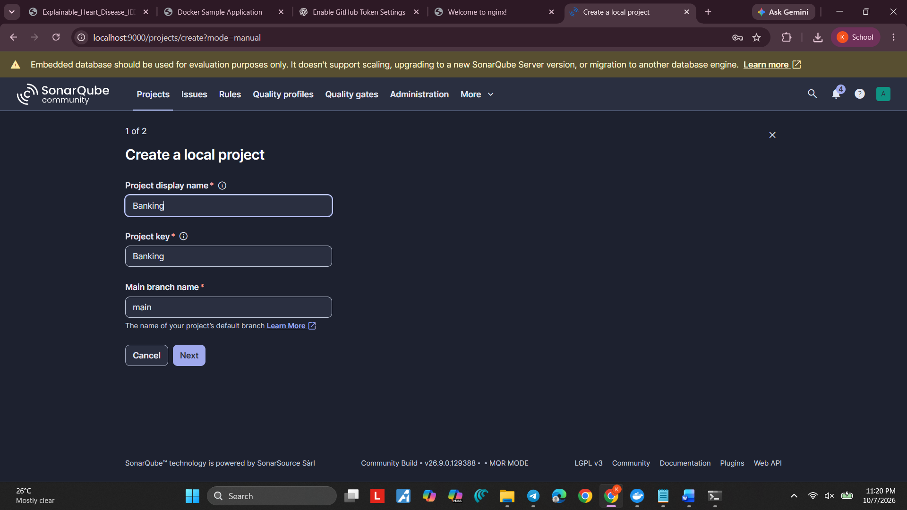
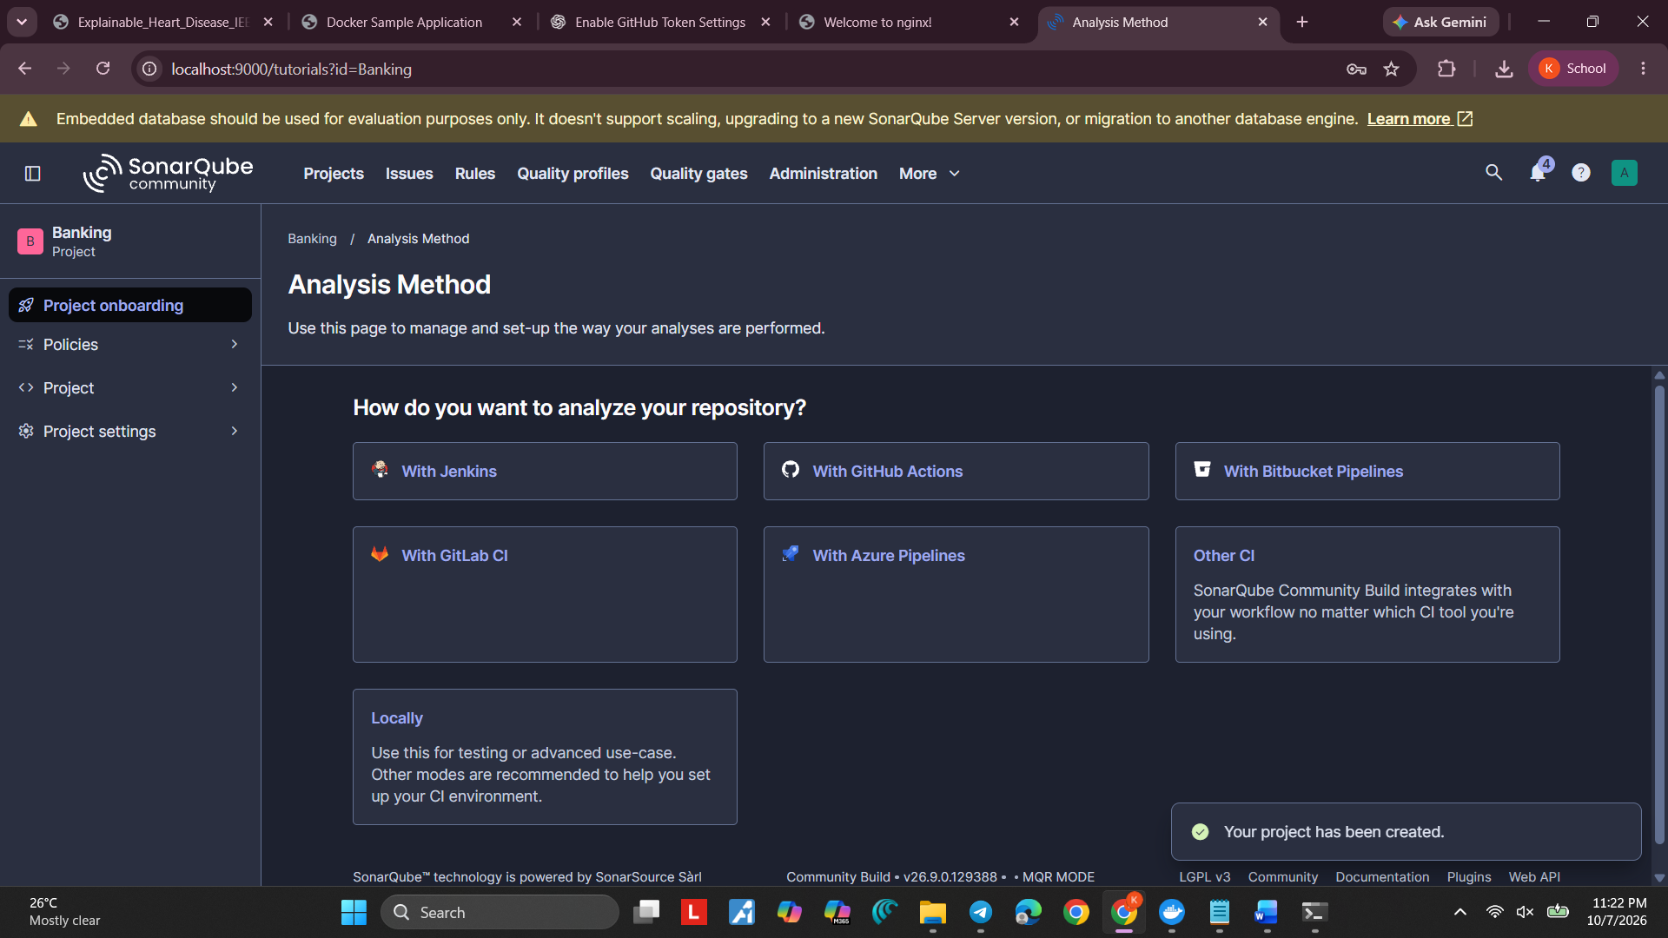

STEP 4 — Create your Java project folder
The structure should be like this:
ASE 8
│
├── sonar-project.properties
│
└── src
│
└── Main.java

sonar-project.properties:
sonar.projectKey=Banking
sonar.projectName=Banking
sonar.sources=src
sonar.host.url=http://localhost:9000
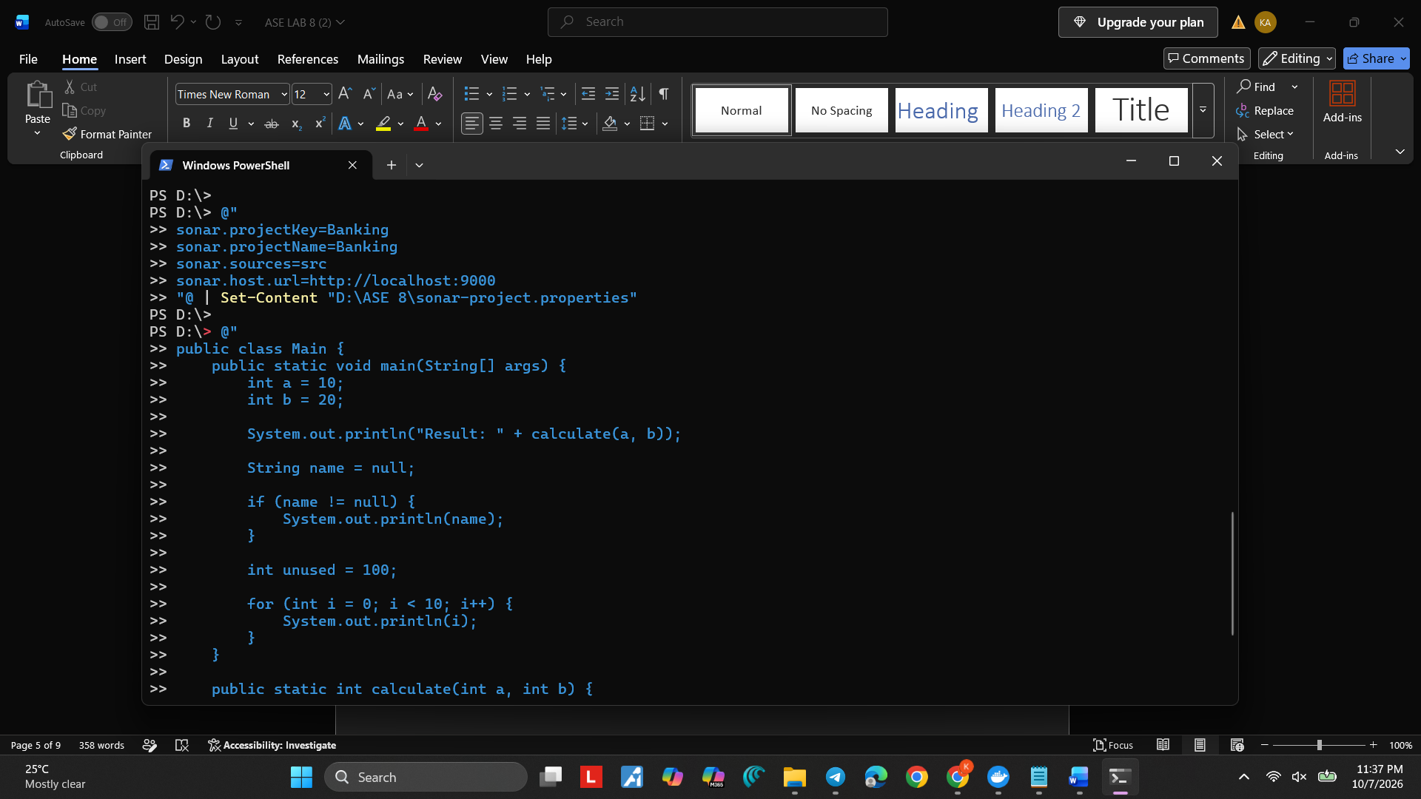

Main.java: (can write your own code if not just copy paste this):
public class Main {

public static void main(String[] args) {

int a = 10;
int b = 20;

System.out.println("Result: " + calculate(a, b));

String name = null;

if (name != null) {
System.out.println(name);
}

int unused = 100;

for (int i = 0; i < 10; i++) {
System.out.println(i);
}
}

public static int calculate(int a, int b) {
return a + b;
}

public static void badMethod() {
int x = 10;
int y = 20;
int z = x + y;

System.out.println("This method is not needed");
}
}

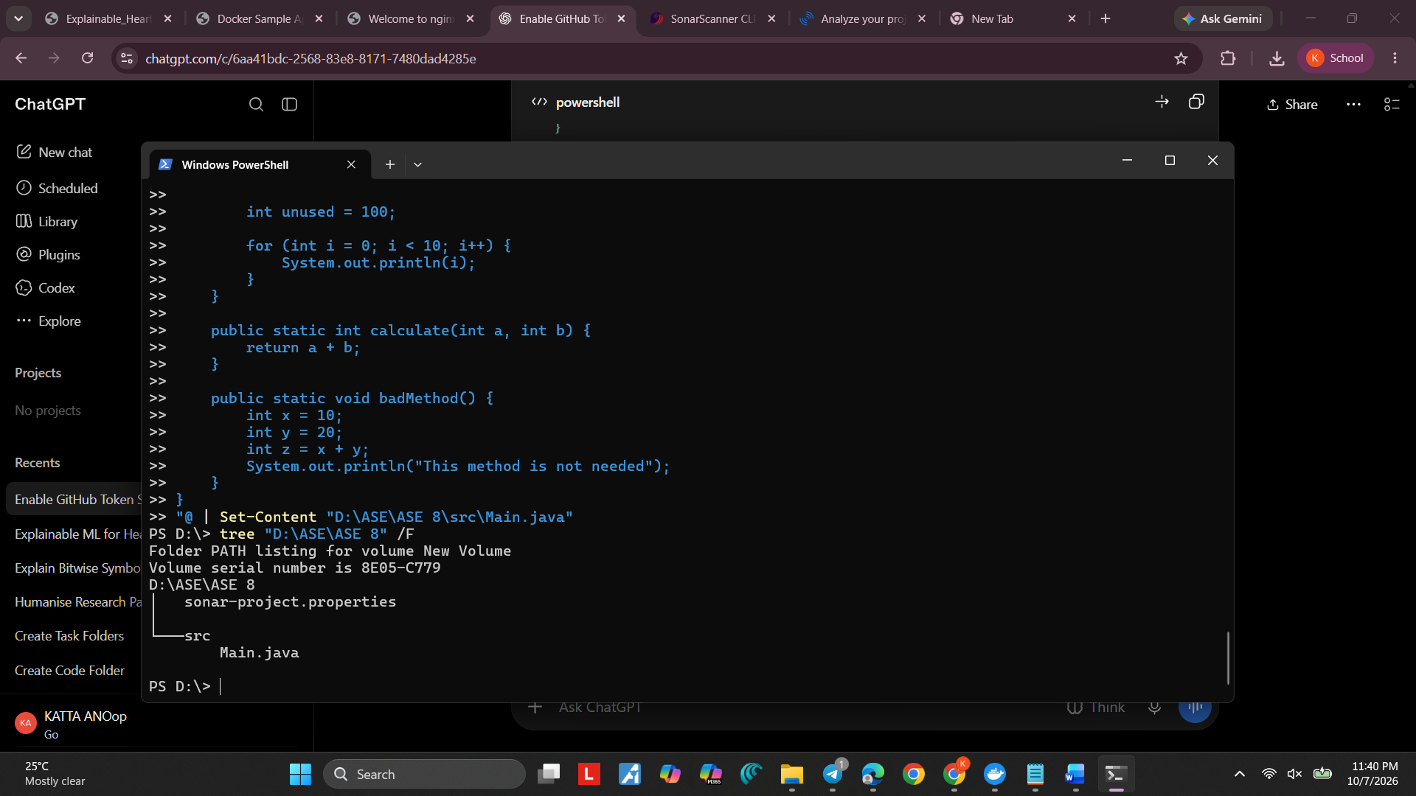

Step 5: Install SonarScanner
https://docs.sonarsource.com/sonarqube-server/analyzing-source-code/scanners/sonarscanner

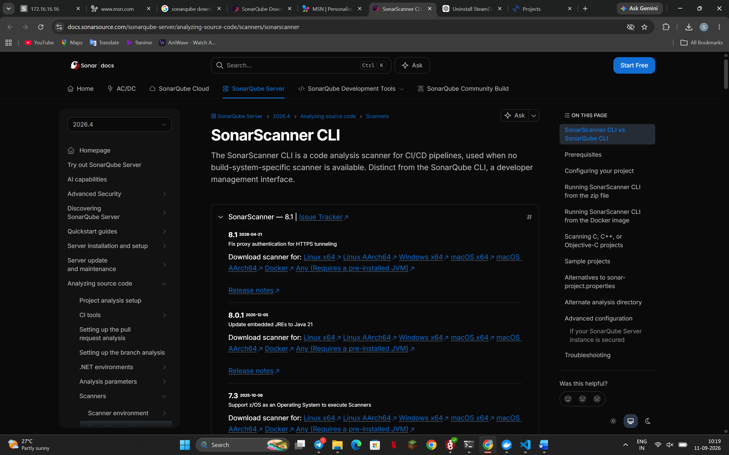
- To check if its installed correctly use: sonar-scanner –version
- 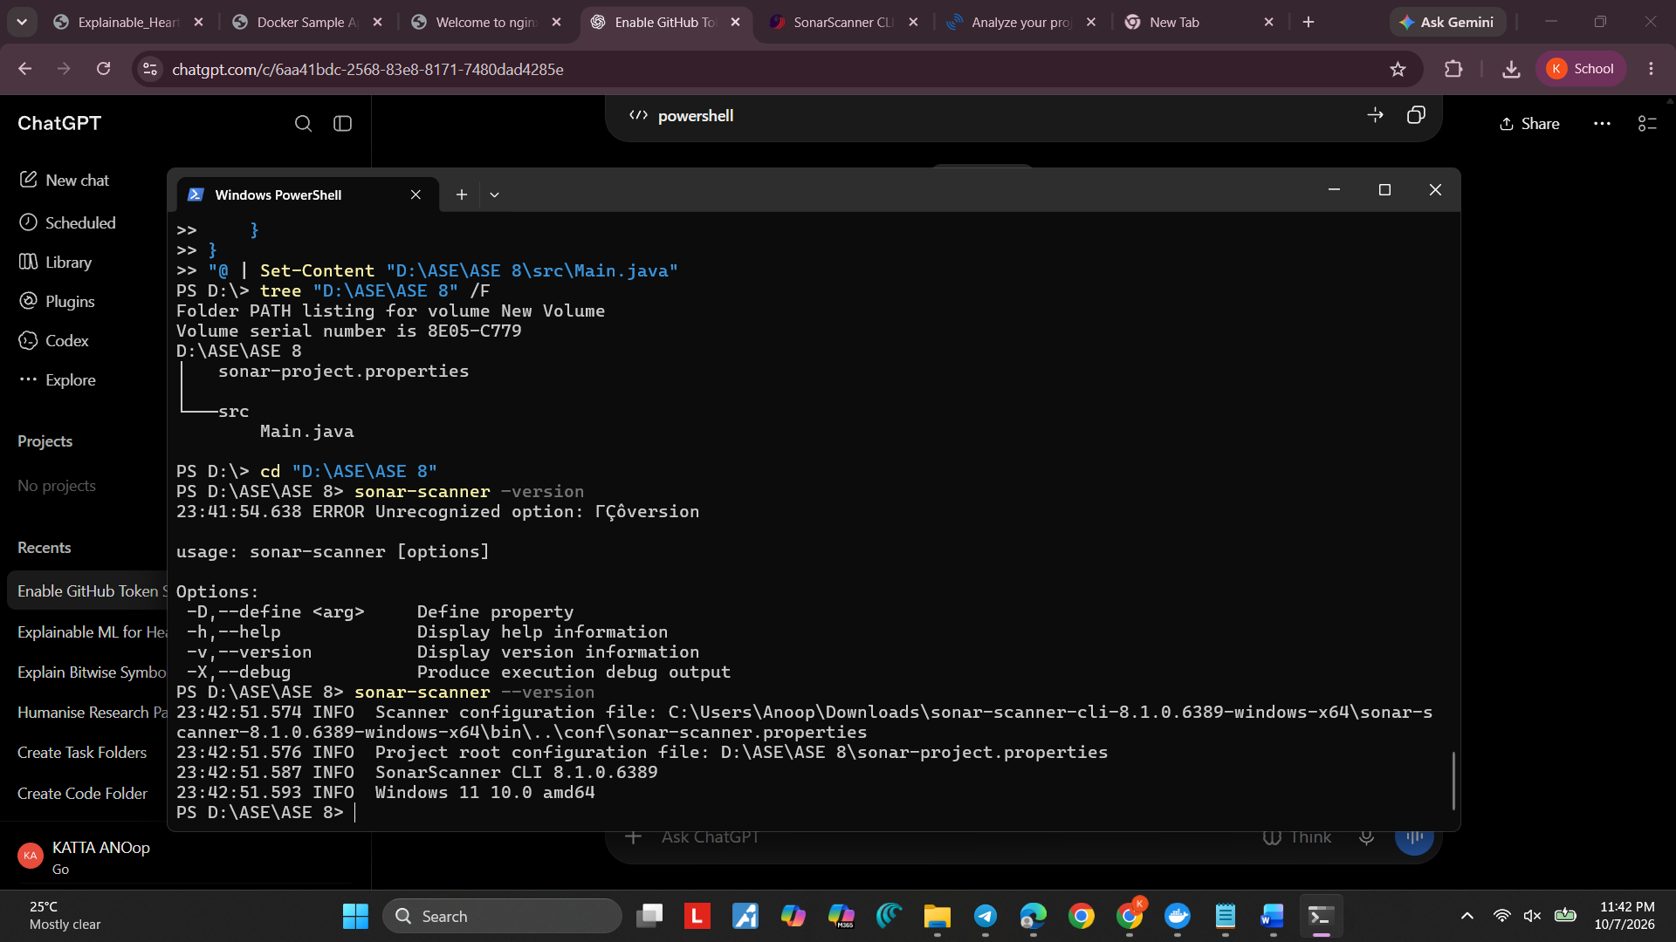
Step 6: Generate SonarQube authentication token
- Go to the localhost:9000, login using the credentials
- After logging in open your profile on the right corner
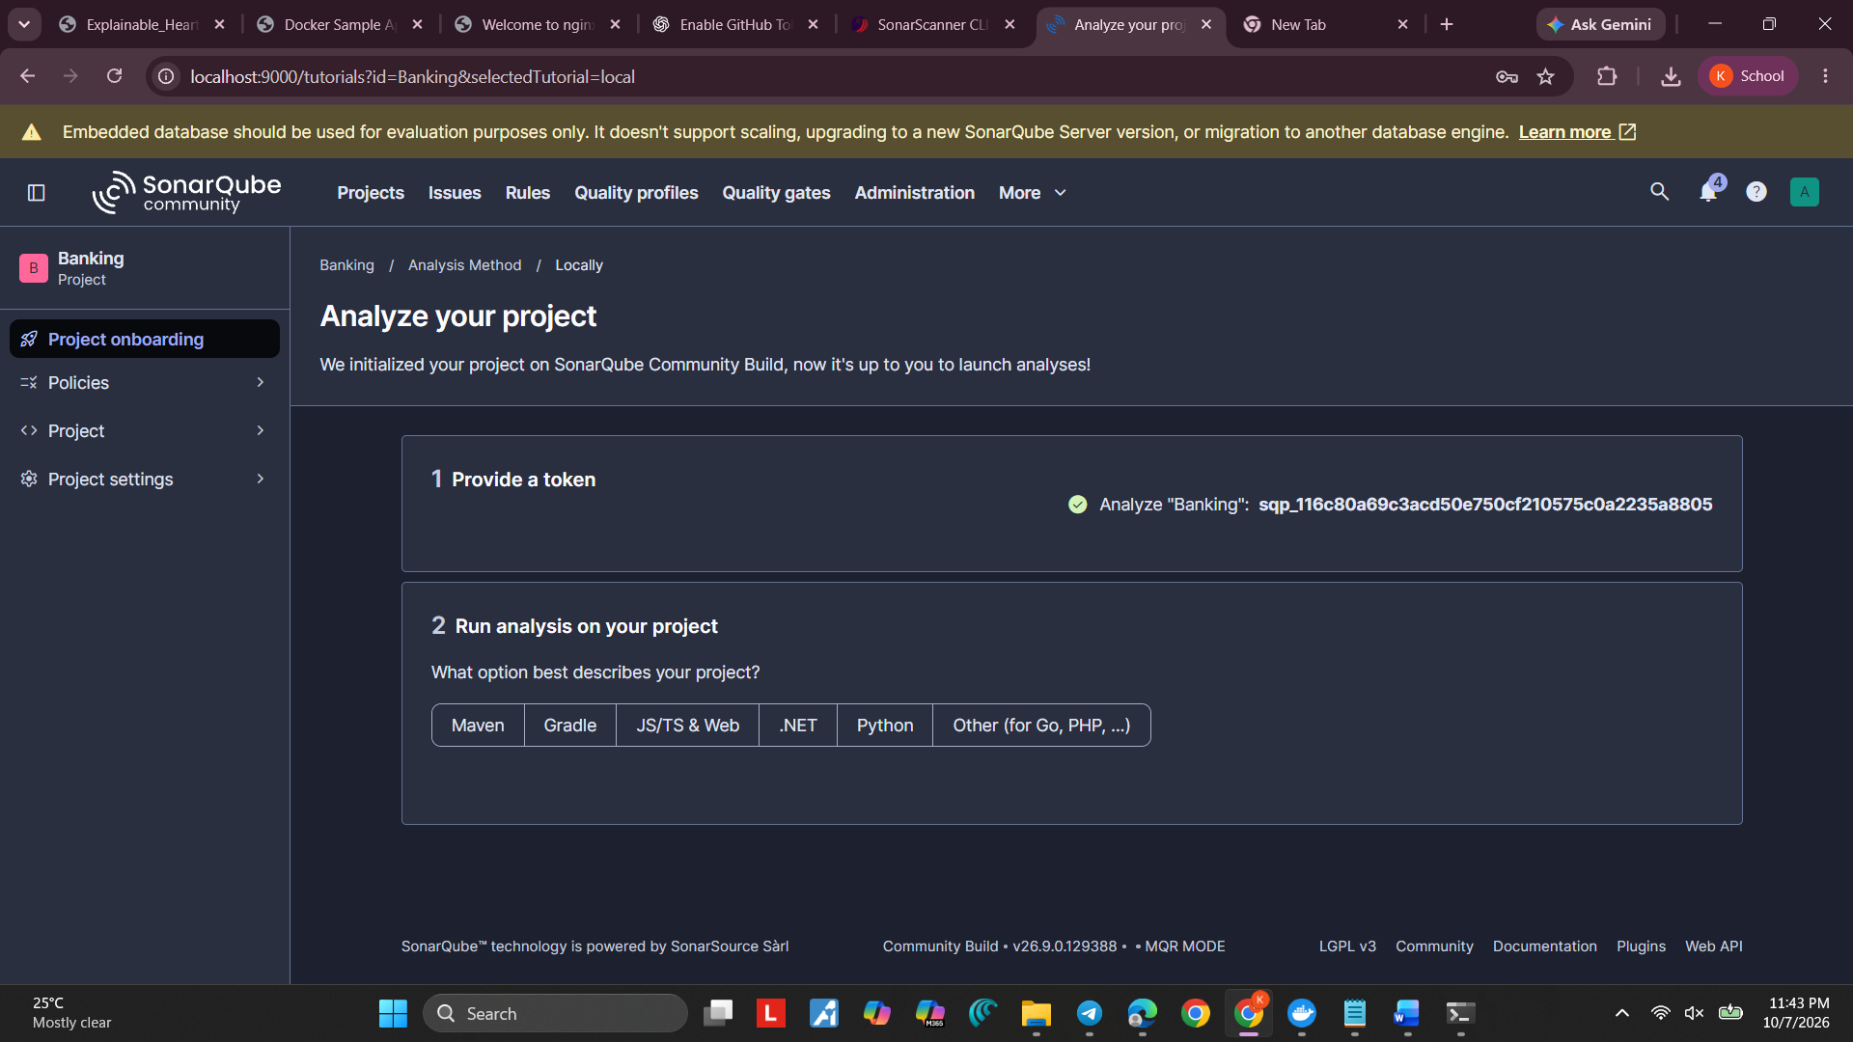

- Then go to the Security option in the left
- Give a name to the token and then select the type as User token and generate it
- Copy the token and open the cmd and run
set SONAR_TOKEN=YOUR_TOKEN
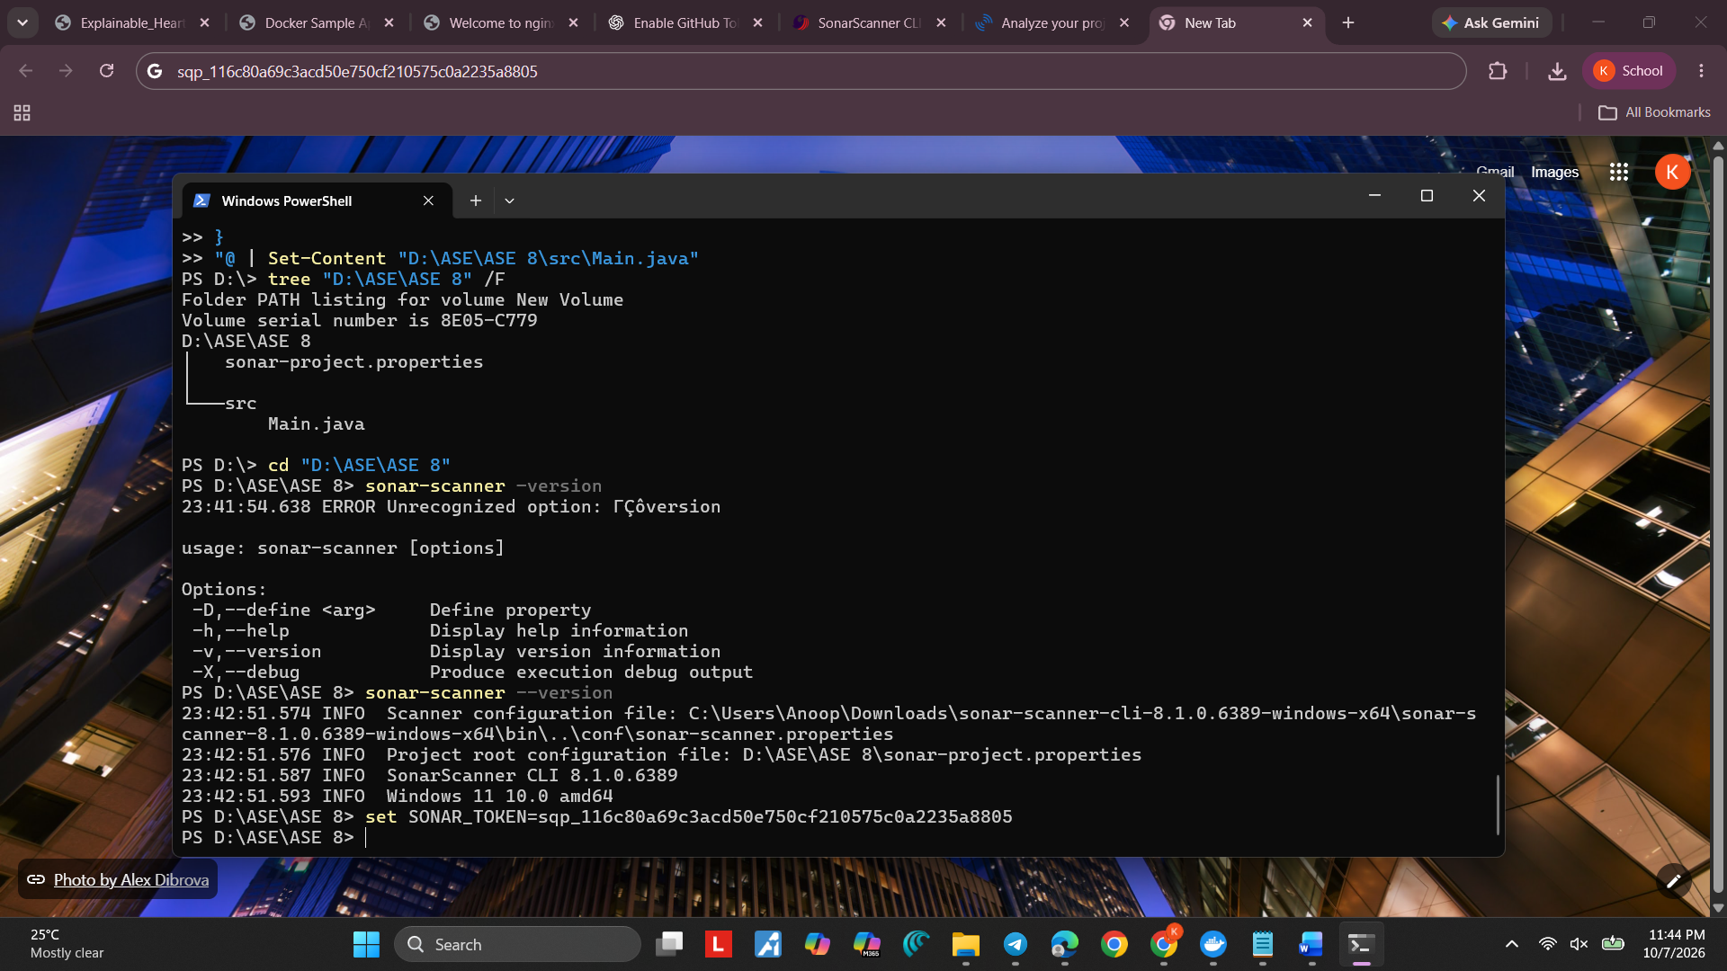

Step 7: Go to your project directory
- Open cmd and then go to your project directory ASE 8

Step 8: Run SonarScanner
- After going to your directory in cmd run the command:
sonar-scanner
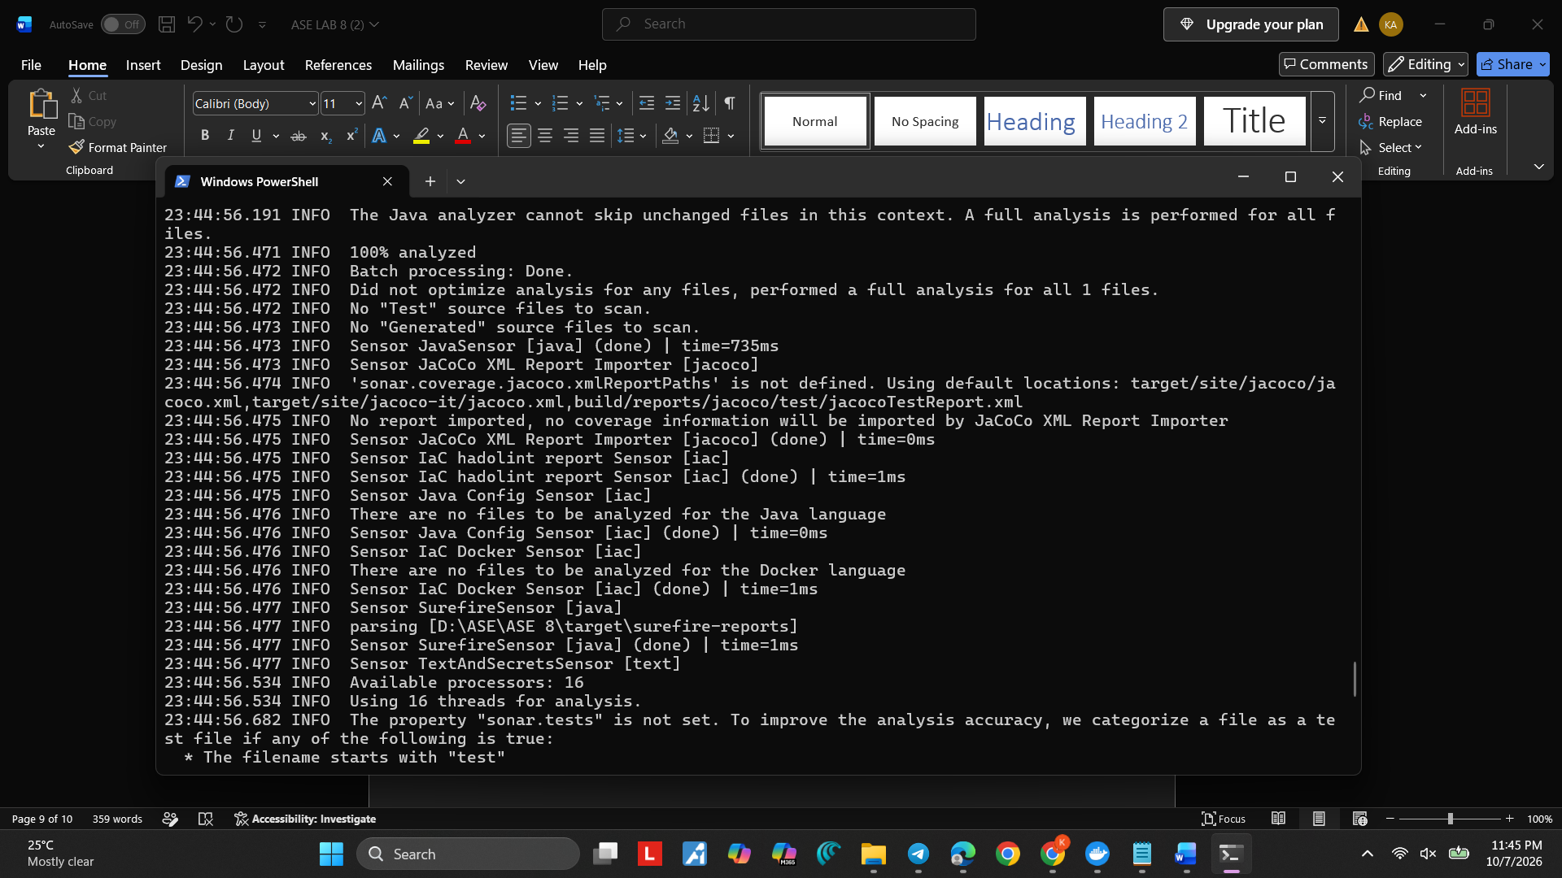
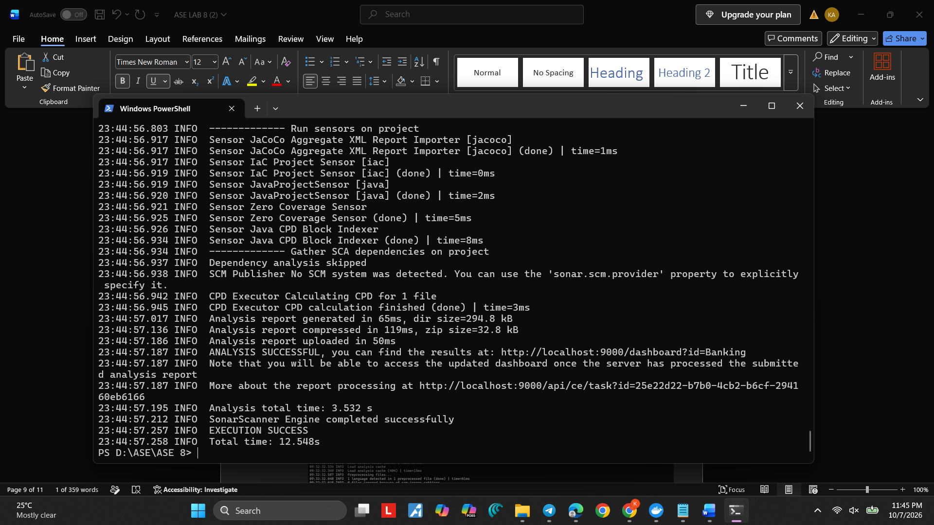

- When you see the execution as successful go the localhost:9000

Step 9: Open your project dashboard
Go to:
http://localhost:9000
Then:
Projects → Banking
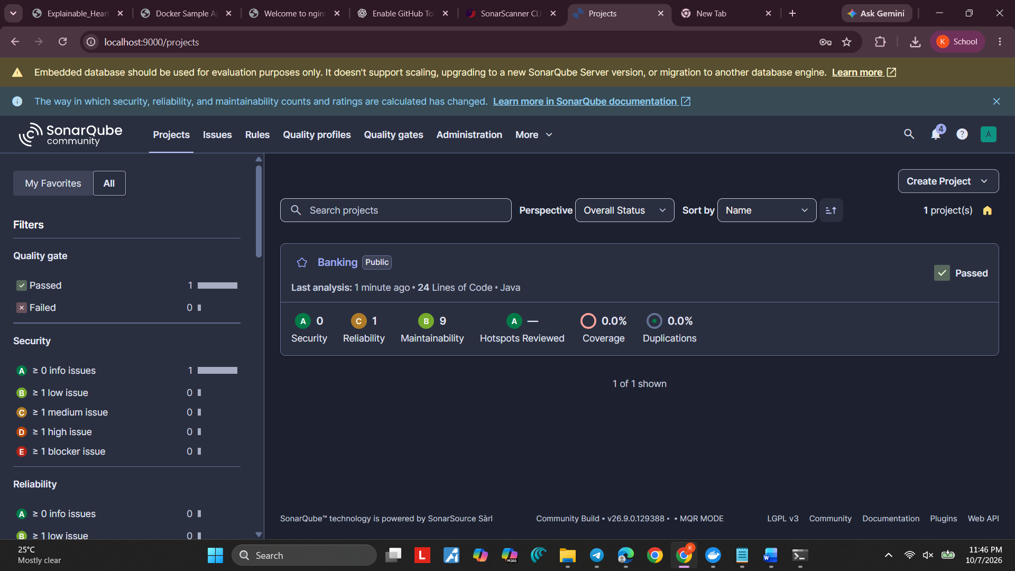

Here u should see your code if its passed or failed

